SOP for calculating discharge using a propeller flowmeter Created by W. Woelmer

Last Update: Aug 28, 2019

1. Choose a cross section of the stream with a relatively defined channel and mark both sides of the stream using re-bar, sticks, etc. (some sort of pole that can be inserted into the sediment)
2. Lay a measuring tape across the width of the stream and record the total stream width
3. At 0.1m intervals along the width of the stream measure the stream depth (cm) using a meter stick
4. At the same location as the depth reading at every interval, also measure the velocity.
   * Record the units that the flowmeter reads (ft/s or m/s)
   * Align the flowmeter so that the propeller is parallel to the direction of stream flow (and the propeller is facing the proper direction according to the arrow on the instrument).
   * Raise the flowmeter approximately 1/3 of the total depth above the stream bed.
   * Read and record the velocity measurement displayed on the flowmeter.
   * NOTE: occasionally, the velocity is below the 0.1 m/s lower detection limit. If this is the case and you see visible water flow, record the velocity as 0.01 m/s and note the discrepancy.
5. Repeat steps 3-4 for each 0.1m across the stream width.
6. Make sure to record the flow meter ID on the field datasheet.

SOP for calculating discharge via the salt injection method at Falling Creek and Beaverdam Reservoirs Created by W. Woelmer

Last Update: Aug 28, 2019

1. Calculate a calibration curve once per sampling day at each reservoir (i.e., there will be one calibration curve for BVR and one for FCR on a given sampling day)
   1. Put a known amount of stream water in bucket (4L usually works well) and record the volume of water on the datasheet
      1. Make sure to scrub the bucket clean in stream water BEFORE measuring water into the bucket
   2. Measure baseline specific conductance in the bucket and record on datasheet
      1. Hit ‘mode’ once after turning on the probe to measurement ‘compensated’

conductivity

* 1. Add 5g of pre-weighed salt and measure specific conductance
  2. Repeat step 1c for 10g, 25g, 50g, and 100g of salt additions for a final salt addition of 190g

1. Select a monitoring site where you will read specific conductance measurements which is in a well-mixed portion of the stream with an obvious channel. At the monitoring site, collect a baseline specific conductance measurement before adding the salt slug upstream. Find a location for the conductivity probe in an unobstructed portion of the stream.
2. Dissolve a known amount of salt in the bucket (~125g of salt per meter of stream width). Make sure all salt is dissolved by using a stirring utensil. Leave the stirring utensil in the bucket so you can rinse it in the stream when you dump the salt slug in Step 5.
3. Select a dumping site upstream of the monitoring site. This site should be ~10x the stream width upstream and in a location where the salt slug will fully mix in the stream quickly.
4. At the dumping site, pour the salt solution quickly into the stream, being sure to rinse remaining residue from bucket and any utensil used to stir the solution into the stream as well.
5. Immediately upon dumping the salt solution, begin timing and recording specific conductance measurements, starting at 0 seconds.
6. Continue collecting specific conductance measurements at given time interval (3-5 seconds) until the specific conductance returns to the baseline reading.
   1. Time intervals can be adjusted once the specific conductance begins to slow in between readings, but the interval change must be recorded on the data sheet.

SOP for calculating discharge via the velocity float method at Falling Creek and Beaverdam Reservoirs Adapted from Virginia Tech Freshwater Ecology Laboratory Methods

Last Update: Dec 16, 2019

1. Measure the width of the stream, exactly perpendicular to the flow direction. The location should be chosen so that the stream is flowing straight and laminarly (no eddies, backwaters, etc.) and there should be no obstructions along the cross-section.
2. Take the total stream width and divide by a convenient number between 15 and 30 to arrive at the width of each measurement interval. Record the interval width and the water depth at the middle of each interval in cm.
3. Mark off a known distance (L) over which it will take the float ≥ 20 s to travel. This distance should overlap the surveyed cross sections and should be located in a relatively straight reach with minimal turbulence.
4. Place float in stream a short distance upstream of the reach so it can reach the speed of the water before passing the first mark.
5. Use a stopwatch to record the time (t) required for the float to travel the marked distance (L). Repeat to obtain an average time (tavg).
6. Calculate velocity (m3/s):
   1. Surface velocity = V = L / tavg
   2. Multiply the mean velocity (V) by the area (A) of each interval (A = depth at center of interval * interval width) to calculate discharge for that interval (m3/s).
   3. Sum the incremental discharge for each interval over all the intervals (m3/s)

SOP for calculating discharge volumetrically using a bucket and stopwatch at tunnel sites

Created by D.W. Howard

Last Update: Jan 13, 2022

This method is intended to be used at sites where using a flowmeter, salt injection, or float are difficult and where the water flow is channelized and allowed to be collected in a bucket with a known volume.

1. Identify a site where water is channelized and could easily be collected using a bucket with a known volume (see Fig 1 for examples of sites with this characteristic)
   1. If there are multiple sites that meet this description (Fig 1; left panel) you will measure discharge at each site and sum them.
2. To measure discharge, you will need a bucket with a known volume (V), a stopwatch, and a way to record data.
3. Once at the site you will time how long it takes the water to fill the bucket (t). Record the time taken to fill the bucket and the volume of water collected. You will repeat this 3 or more times at each site with flowing water.
4. To calculate discharge (Q), divide the volume collected (V) by the time it took to collect (t) for each rep. Q = V/t
5. After this is calculated for each rep, average these values to obtain a mean discharge value for that site.
6. If there were multiple flows at one site (e.g., Fig 1; left panel), follow steps 3-5 for each location and them sum across each location to obtain the discharge for that site.
7. These calculations are shown in the excel workbook named CCR_VolumetricFlow_discharge_Calc_example.xlsx, where data collected in the filed is added to columns F, G, and H.
   1. Discharge is then calculated per rep in row I where volume is divided by time.
   2. Discharge is then averaged across reps in column J.
   3. And if there were multiple flows at one site, these are then averaged in column K.
   4. Discharge can then be converted to desired units in column M
      1. In this example we convert from liter per seconds measured in the field to cubic meters per second.

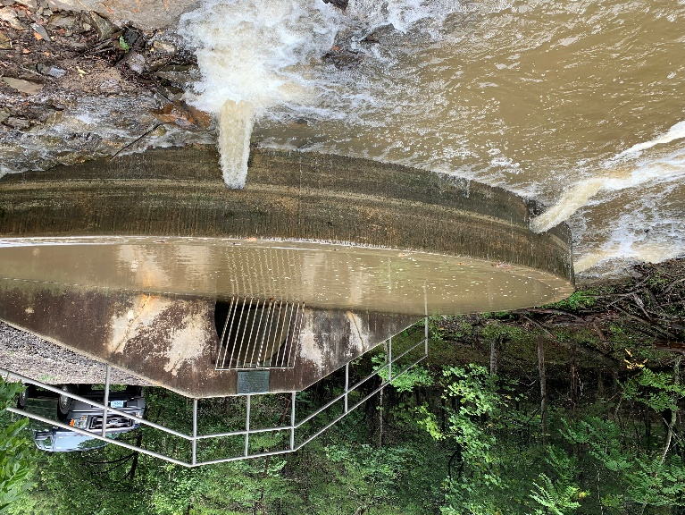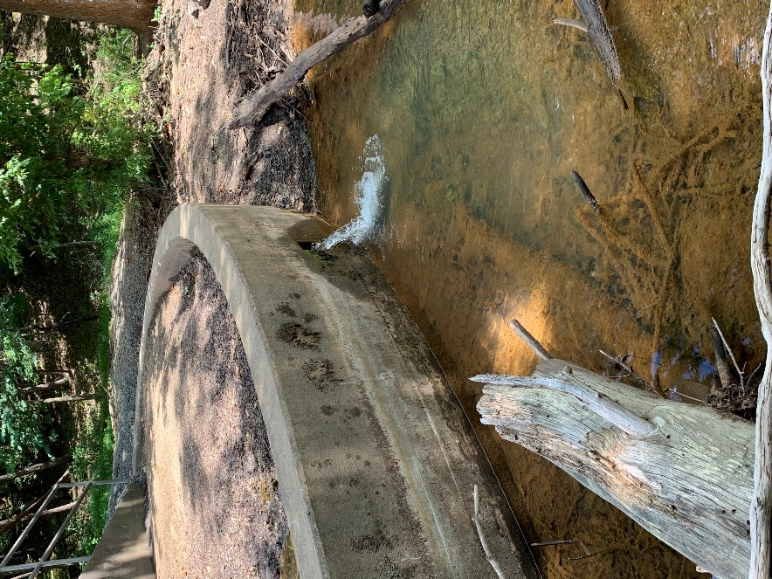

Fig 1: Examples of sites where this method could be used.